GCNU1003 Speaking of Statistics (1004) - Assignment 5 solution
Chapter 6
1. Which of the following could not be probability density functions for a continuous random variable? Explain. Hint: Find the area under the function f (x).
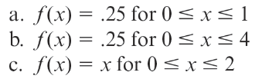
Ans: a. and c. could not be probability density functions for a continuous random since the total area under the curve f(x) is not equal to 1.

2. Suppose the times required for a cable company to fix cable problems in its customers’ home are uniformly distributed between 10 minutes and 25 minutes.
a. What is the probability that a randomly selected cable repair visit will take at least 15 minutes?
b. What is the probability that a cable repair visit will take over 20 minutes given that it takes over 15 minutes?
c. Find the mean and standard deviation for the times.

Ans:
a. Let x be the amount of time that a randomly selected cable repair visit will take.
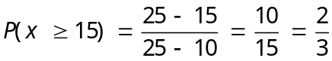
b. The conditional probability that a cable repair visit will take over 20 minutes given that it takes over 15 minutes is
c.
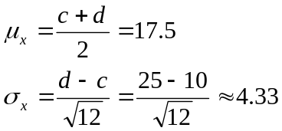

3. The Layton Tire and Rubber Company wishes to set a minimum mileage guarantee on its new MX100 tire. Tests reveal the mean mileage is 67,900 with a standard deviation of 2,050 miles and the distribution of miles follows the normal distribution. They want to set the minimum guaranteed mileage so that no more than 4 percent of the tires will have to be replaced. What minimum guaranteed mileage should Layton announced?
Ans:
The fact of this case is shown in the following diagram, where k represents the minimum guaranteed mileage.
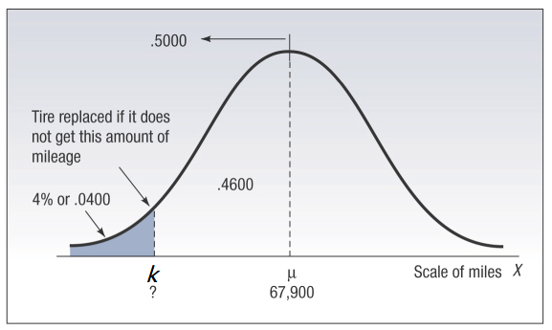
So we have
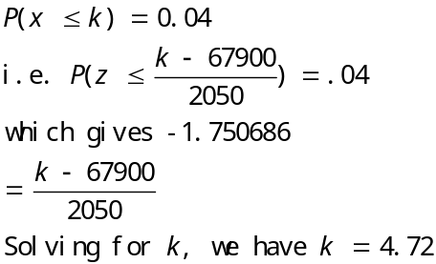

K=64312.5 not 4.72

4. An investment broker reports that the yearly returns on common stocks are approximately normally distributed with a mean return of 12.4 percent and a standard deviation of 20.6 percent.
  - Find the probability that a randomly selected
- Common stock will give a positive yearly return.
- Common stock will give more than a 10 percent return.
- Common stock will give a loss of at least 10 percent.
  - What percent of yearly returns are at or below the 10th percentile of the distribution of yearly returns? What percentages are at or above the 10th percentile? Find the 10th percentile of the distribution of yearly returns.
Ans:
Let x be the yearly return on a randomly selected common stock.
Given μ = 12.4, σ = 20.6
a.[1] P(x > 0) = P(z > )= P(z > –.60) =P(z < .60) = .7257
a.[2] P(x > 10) = P(z > –.12) = .5478
a.[3] P(x ≤ –10) = P(z ≤ –1.09) = 1– P(z ≤ 1.09)=1–.8621 = .1379
b. According to the definition of percentile, we know that 10 percent of yearly returns are at or below the 10th percentile of the distribution of yearly returns; 90 percent are at or above the 10th percentile.
Let k be the 10th percentile of the distribution of yearly returns.
Then P(x ≤ k) = 0.1 i.e. 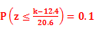 which gives (k–12.4)/20.6= –1.28, thus k=-13.968.
5. Suppose that the random variable z has a standard normal distribution.
- Sketch and find each of the following probabilities using the normal table.
- P(z ≥ –1)
- P(–2.5 ≤ z ≤ .5)
- Sketch each of the following z values, and use the normal table to find each z value.
Ans.
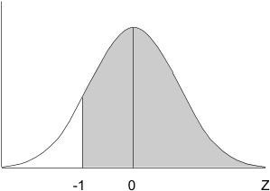
a.[1]

P(z ≥ –1) = P(z ≤ 1) =.8413
a.[2]
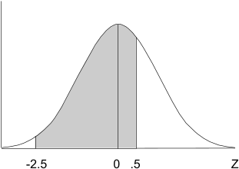

P(–2.5 ≤ z ≤ .5) = P( z ≤ .5) – P(z ≤ –2.5)= P( z ≤ .5) – (1– P(z ≤ 2.5))=.5199 – (1– .9938) = 0.6853
b.[1]
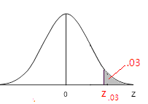
b.[2]
